1. A wetland is an area that is permanently, seasonally or intermittently waterlogged or inundated with water. The different types of wetlands include a Basin, Flat, Channel, Slope and Highland. A basin contains a vast network of rivers, creeks and watercourses. (Department of the Environment and Energy, 2020)

**1 mark- why is it important?**

1. The Ramsar convention is a treaty signed by nations to conserve natural resources. It’s important because

**? is it just natural resources?-this isn’t compete- 0 marks**

1. The wetland I’m doing qualifies for the 1st, 3rd, 5th and 6th Criterion. **(1 mark)**

- It meets the first criteria because it’s a natural wetland

- It meets the third criteria because It is one of the few places that have living thrombocytes in inland, hyposaline waters.

- It meets the fifth criteria because it supports in excess of twenty thousand water birds annually

- It meets the sixth criteria because over 1% of the world population of several waterbird species regularly use the Peel-Yalgorup for the services the wetland provides such as food, shelter, nesting and moulting sites.

**3 marks**

1. The Geographical coordinates of the Peel-Yalgorup system are Latitude: 32°32' S to 33°06' S; Longitude: 115°37' E to 115°47' E **Closest Town?**

**3 marks**

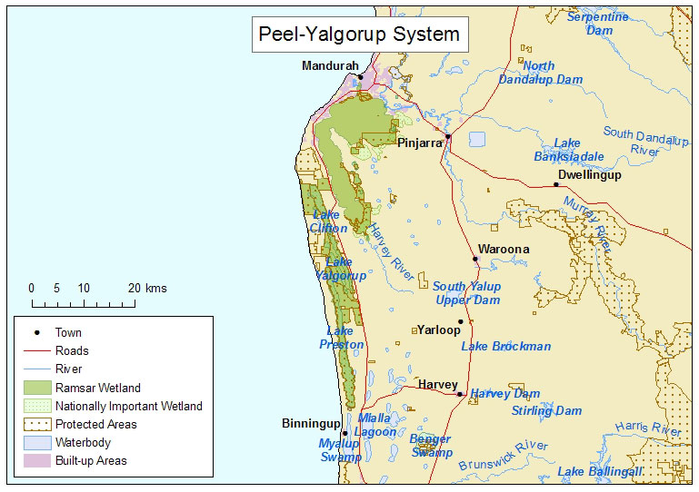



5. The Peel-Yalgorup system is the most important are for water birds in south Western Australia.

One of the few places where living thrombolites occur in inland water.

Swan Coastal Plain

The Peel-Harvey Wetland receives drainage from a large number of drainage systems. This serves as flood mitigation.

**2 marks- this is worth 8 marks and requires you to explain the type of wetland, hydrological values, average annual rainfall and temperature etc.**

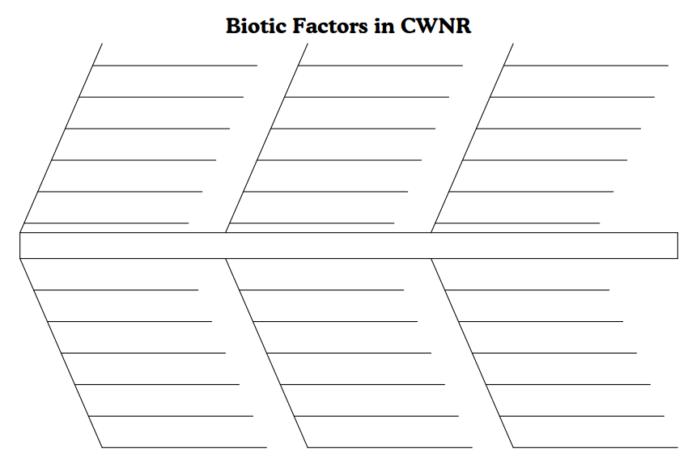6. **You need to explain why each are important in this wetland-include scientific names-2 marks**

Red-necked Avocet

Red-capped Plover

Banded Stilt

A chestnut brown head with a white eye-ring and a long, upturned black bill

Forna

Blue Leshenaultias

Spider Orchids

Red and Green Kangaroo Paws

7. The Peel-Yalgorup wetland is an important fishery. The species include King George Whiting, Black Bream, Cobbler, Blue Swimmer Crabs and Western King Prawns. It is estimated that fishing operations in the wetland are worth about $1 million per annum in fish.

**2 marks -why else? Any cultural reasons?**

8. The Peel-Yalgorup wetland is used mostly for fishing and boating, while there are small areas in the wetland for residential purposes. Recreational activities within the wetland include bushwalking, camping, motorbiking, four-wheel driving, jet skiing, water skiing and swimming.

**3 marks- You need the how!**

**If the land or water is used by humans how do these influence the ecological character of your wetland?**

BIBLIOGRAPHY:

Department of the Environment and Energy. (2020). The Ramsar Conventions on Wetlands. [online] Available at: <https://www.environment.gov.au/water/wetlands/ramsar> [Accessed 10 Feb. 2020].

Peel-Yalgorup System - Australian Ramsar site no. 36. (2020). Retrieved 11 February 2020, from <https://www.environment.gov.au/cgi-bin/wetlands/ramsardetails.pl?refcode=36>

Department of the Environment and Energy. (2020). Retrieved 11 February 2020, from <https://www.environment.gov.au/water/wetlands/ramsar/criteria-identifying-wetlands>

WA Ramsar Sites. (2020). Retrieved 11 February 2020, from <https://www.environment.gov.au/water/topics/wetlands/database/maps/pubs/wa.pdf>

(2020). Retrieved 13 February 2020, from <https://library.dbca.wa.gov.au/static/FullTextFiles/024211.pdf>

(2020). Retrieved 19 February 2020, from <https://www.dpaw.wa.gov.au/images/documents/conservation-management/wetlands/ramsar/peel-yalgorup-ramsar-site-ecd-with-disclaimer.pdf>

(2020). Retrieved 19 February 2020, from https://www.dpaw.wa.gov.au/images/documents/conservation-management/wetlands/ramsar/information_sheets/RIS_Peel_Yalgorup_2007.pdf

Flora and Fauna - Shire of Murray. (2020). Retrieved 20 February 2020, from <https://www.murray.wa.gov.au/tourism/attractions/flora-fauna/>

**You included an intext reference for the first question only- 2 marks**

**Total: 19/39 + 10/21 = 29/60 = 48.3%**